**Rockbuster Stealth**

**Data Dictionary**

Aysha Samsudeen

1. Entity Relationship Diagram (ERD) 3
2. Tables 4
   1. Fact Tables 4

Payment 4

Rental 4

* 1. Dimensions Tables 5

Film_actor 5

Inventory 5

Film_category 5

Customer 6

Staff 6

Actor 7

Film 7

Category 8

Language 8

Address 8

City 9

Country 9

# Entity Relationship Diagram (ERD) :

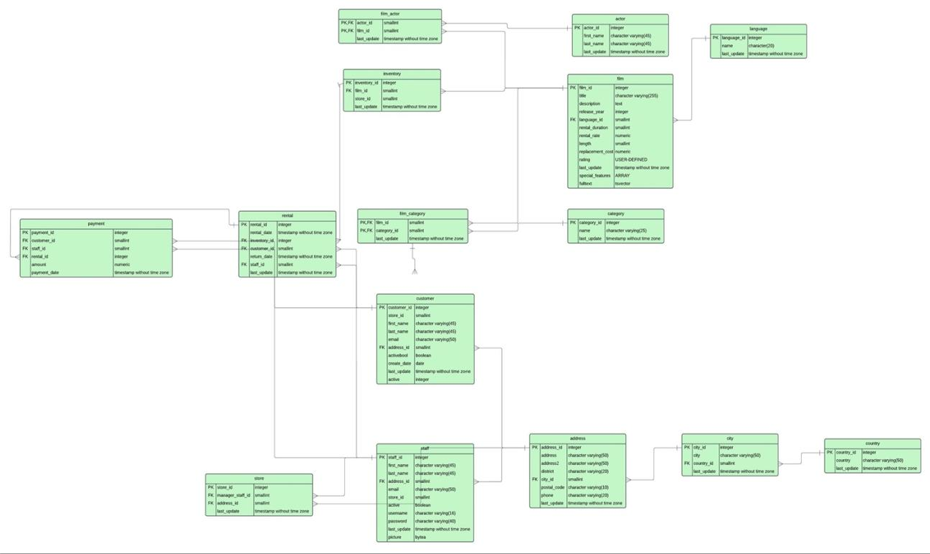

1. **Tables :**

# Fact Tables :

Payment

|  |  |  |  |  |
| --- | --- | --- | --- | --- |
| **Column** | **Data Type** | **Description** | **Column linked**  **to** | **Column linked**  **from** |
| payment_id | SERIAL | Each payment has a unique ID number |  |  |
| customer_id | SMALLINT | Each customer is given an ID number(small integer values) | customer.  customer_id | rental.customer_id |
| staff_id | SMALLINT | Each staff is given a unique ID number ( small integer values) | staff.staff_id | rental.staff_id |
| rental_id | INTEGER | Each rental is given a unique ID number ( small integer values) | rental.rental_id |  |
| amount | NUMERIC(5,2) | Money spent on each film that is rented |  |  |
| payment_date | TIMESTAMP(6) WITHOUT TIME ZONE | date and time  payment was made/confirmed |  |  |

Rental

|  |  |  |  |  |
| --- | --- | --- | --- | --- |
| **Column** | **Data Type** | **Description** | **Column linked to** | **Column linked from** |
| rental_id | SERIAL | Each given a ID no( unique identifier number) |  | payment.rental_id |
| rental_date | TIMESTAMP(6)  WITHOUT TIME ZONE | Each film has a rental date/ a date it is rented out |  |  |
| inventory_id | INTEGER | Unique indetifier number for each rental date | inventory. inventory_id |  |
| customer_id | SMALLINT | Each customer has a unique identifier number | customer. customer_id | payment. customer_id |
| return_date | TIMESTAMP(6) WITHOUT TIME ZONE | Each film has a return rental date |  |  |
| staff_id | SMALLINT | Each staff member has a unique staff number ( small integer values) | staff.staff_id | Payment  staff_id |

# Dimension Tables:

Film_actor

|  |  |  |  |  |
| --- | --- | --- | --- | --- |
| **Column** | **Data Type** | **Description** | **Column linked to** | **Column linked from** |
| actor_id | SMALLINT | unique identifier numbers for actor. | actor.actor_id |  |
| film_id | SERIAL | unique identifier of films | film.film_id |  |
| last_update | TIMESTAMP(6) WITHOUT TIME ZONE | The information entered in the table last updated on a data and time (The time with up to 6 digits) |  |  |

Inventory

|  |  |  |  |  |
| --- | --- | --- | --- | --- |
| **Column** | **Data Type** | **Description** | **Column linked to** | **Column linked from** |
| inventory_id | SERIAL | Each inventory given a ID no- unique identifier numbers | rental. inventory_id |  |
| film_id | SMALLINT | Each film given a number id (small integer values) | film.film_id |  |
| store_id | SMALLINT | Each store given a number id (small integer values) | store.store_id |  |
| last_update | TIMESTAMP(6)  WITHOUT TIME ZONE | The information entered in the table last updated on a  data and time (The time with up to 6 digits) |  |  |

Film_category

|  |  |  |  |  |
| --- | --- | --- | --- | --- |
| **Column** | **Data Type** | **Description** | **Column linked to** | **Column linked from** |
| film_id | SMALL INT | Each film has a unique film identifier | film.film_id |  |
| category_id | SMALLINT | Films are categorized by ID numbers | category. category_id |  |
| last_update | TIMESTAMP(6) WITHOUT TIME ZONE | date and time of last record update |  |  |

Customer

|  |  |  |  |  |
| --- | --- | --- | --- | --- |
| **Column** | **Data Type** | **Description** | **Column linked to** | **Column linked from** |
| customer_id | SERIAL | unique identifier of customer | rental. cusomer_id payment.  customer_id |  |
| store_id | SMALLINT | Unique store identifier |  |  |
| first_name | CHARACTER  VARYING(45) | customer first name (Different up to 45 characters) |  |  |
| last_name | CHARACTER VARYING(45) | customer last name (Different up to 45 characters) |  |  |
| email | CHARACTER  VARYING(50) | customer email  address |  |  |
| address_id | SMALLINT | Unique identify number for customers |  | address.  address_id |
| activebool | BOOLEAN | The state of the customers if they are active or inactive members give “True or False” (True or false values of 0 and 10) |  |  |
| create_date | DATE | date customer’s profile was created |  |  |
| last_update | TIMESTAMP(6) WITHOUT TIME ZONE | The information entered in the table last updated on a data and time |  |  |
| active | INTEGER | A state of the customers if they are active or inactive members give a value  (integer values) |  |  |

Staff

|  |  |  |  |  |
| --- | --- | --- | --- | --- |
| **Column** | **Data Type** | **Description** | **Column linked to** | **Column linked from** |
| staff_id | SERIAL | unique identifier number of  staff |  |  |
| first_name | CHARACTER VARYING(45) | staff first name (45 characters) |  |  |
| last_name | CHARACTER VARYING(45) | staff last name ( 45 characters) |  |  |
| address_id | SMALLINT | Each address given an ID number) | address.  address_id |  |
| email | CHARACTER  VARYING(50) | staff email address |  |  |
| store_id | SMALLINT | Each store given a unique identifier | store.store_id |  |
| active | BOOLEAN | active or not (true/false) | rental.staff_id, payment.  staff_id |  |
| username | CHARACTER  VARYING(50) | staff username |  |  |
| password | CHARACTER VARYING(40) | staff password |  |  |
| last_update | TIMESTAMP(6) WITHOUT TIME ZOND | date and time of last record update |  |  |
| picture | BYTEA | staff photo |  |  |

Actor

|  |  |  |  |  |
| --- | --- | --- | --- | --- |
| **Column** | **Data Type** | **Description** | **Column linked to** | **Column linked from** |
| actor_id | SERIAL | unique identifier number of actor | film_actor. actor_id |  |
| first_name | CHARACTER VARYING(45) | actor first name |  |  |
| last_name | CHARACTER  VARYING(45) | actor last name |  |  |
| last_update | TIMESTAMP(6)WITHOUT TIME ZONE | The information entered in the table last updated on a data and time (The time with up to 6 digits) |  |  |

Film

|  |  |  |  |  |
| --- | --- | --- | --- | --- |
| **Column** | **Data Type** | **Description** | **Column linked to** | **Column linked from** |
| film_id | SERIAL | unique identifier of film | film_category. film_id, film_actor.  film_id, inventory.film_id |  |
| title | CHARACTER VARYING (255) | title name of film( 255 characters) |  |  |
| description | TEXT | description of film |  |  |
| release_year | year | year film was  released |  |  |
| language id | SMALLINT | Each film language - each language given a number id (small integer values) | language. language_id |  |
| rental_duration | SMALLINT | number of days film was rented for |  |  |
| rental_rate | NUMERIC(4,2) | Price of each film rented per day |  |  |
| length | SMALLINT | film length (minutes) |  |  |
| replacement_cost | NUMERIC(5,2) | cost to replace the film |  |  |
| rating | mpaa_rating | which age groups can view the film (G, PG,PG-13, ect) |  |  |
| last_update | TIMESTAMP(6)  WITHOUT TIME ZONE | The information entered in the table last updated on a data and time |  |  |
| special_featur es | TEXT[] | special features of the film/genre |  |  |
| fulltext | TVSECTOR | Each film key words (Functions for full text search) |  |  |

Category

|  |  |  |  |  |
| --- | --- | --- | --- | --- |
| **Column** | **Data Type** | **Description** | **Column linked to** | **Column linked from** |
| category_id | SERIAL | Each film genre | film_category.  category_id |  |
| name | CHARACTER  VARYING(25) | category name |  |  |
| last_update | TIMESTAMP(6)WITHOUT TIME ZONE | date and time of last  record update |  |  |

Language

|  |  |  |  |  |
| --- | --- | --- | --- | --- |
| **Column** | **Data Type** | **Description** | **Column linked to** | **Column linked from** |
| language_id | SERIAL | Each language given a number id - unique identifier values | film.language_id |  |
| name | CHARACTER(20) | Each film language - made up of 20 characters or more |  |  |
| last_update | TIMESTAMP(6) WITHOUT TIME ZONE | The information entered in the table last updated on a  data and time |  |  |

Address

|  |  |  |  |  |
| --- | --- | --- | --- | --- |
| **Column** | **Data Type** | **Description** | **Column linked to** | **Column linked from** |
| address_id | SERIAL | Each store has been given a unique ID no | staff.address_id, store.  address_id |  |
| address | CHARACTER VARYING(50) | Each customer and staff main address |  |  |
| address2 | CHARACTER  VARYING(50) | Each customer and staff address - (Different characters up to 50 characters) |  |  |
| district | CHARACTER  VARYING(20) | name of the district |  |  |
| city_id | SMALLINT | Each customer and staff address - postal code/zip code (Different characters up to 10 characters) | city.city_id |  |
| postal_code | CHARACTER VARYING(10) | postal code details |  |  |
| phone | CHARACTER VARYING(20) | Each customer and staff phone number |  |  |
| last_update | TIMESTAMP(6)WITHOUT TIME ZONE | Date for each payment made |  |  |

City

|  |  |  |  |  |
| --- | --- | --- | --- | --- |
| **Column** | **Data Type** | **Description** | **Column linked to** | **Column linked from** |
| city_id | SERIAL | Each store given a unique ID | address.city_id |  |
| city | CHARACTER VARYING(50) | Each customer and staff address - city name (Different characters up to 50 characters) |  |  |
| country_id | SMALLINT | Each country given a number id (small integer values) | country.  country_id |  |
| last_update | TIMESTAMP(6) WITHOUT TIME ZONE | Date for each payment made (The time with up to 6 digits) |  |  |

Country

|  |  |  |  |  |
| --- | --- | --- | --- | --- |
| **Column** | **Data Type** | **Description** | **Column linked to** | **Column linked from** |
| country_id | SMALLINT | Each store given a id number | city.country_id |  |
| country | CHARACTER  VARYING(50) | Each customer and staff address - country |  |  |
| last_update | TIMESTAMP(6)WITHOUT TIME ZONE | Date of each payment |  |  |